## Chapter 2

## Literature Survey

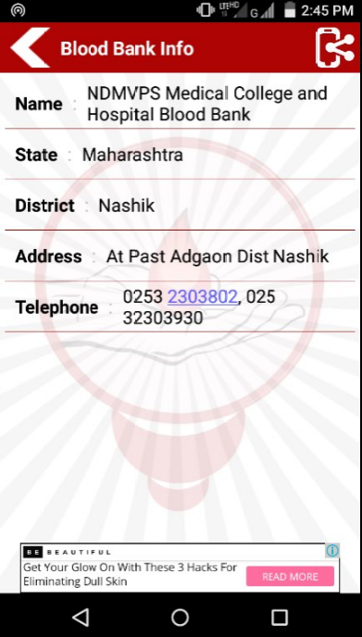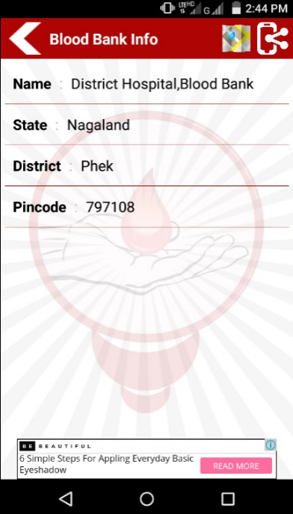2.1 Blood Donation app ‘National Blood Banks Directory’ was developed in the year 2016 for the purpose of donating and receiving the blood. This app contains state/city wise list of Blood banks. This app is useful for particular area not universally. In fig. 2.1.1. Telephone is not mentioned for contact.

Fig.2.1.1: Screenshot of Blood Banks India Fig.2.1.2: Screenshot of Blood Banks India

Directory of Nagaland state Directory of Maharashtra state